
IC factor (carb insulin ratio)
Contribution to the discussion among DIY loopers
The author assumes no liability V.3.2 Jan25

- What is the IC (or CIR) factor?
1.1 To determine a user bolus
1.2 To calculate carb absorption
1.2.1 Basic calculation
1.2.2 Dynamic carb absorption in oref loops
1.2.3 Dynamic carb absorption in iOS Loop
1.3 IC can vary (see also 7.)
- Rough estimates for your IC (or CIR)
- „Experimental“ determinations at meal times
3.1 Basal rate first
3.2 Determinations for each meal time
3.3 Using the IC to set a meal bolus
3.4 What when your bolus wears out?
- Determination of IC via other factors
- Avoiding high glucose
- IC tuning in Hybrid Closed Loop
- Sensitivity-adjusted IC (carb ratios)
7.1 Circadian pattern
7.2 Temp. adaptations to sensitivity
7.3 Automatic adaptions using dynamic carb ratio?
- Limited role of IC in Full Closed Loop

- What is the IC factor (CIR ratio)?
Note: In this paper we use the abbreviation IC. It is the carb/insulin ratio (unit is g/U), and in iOS often abbreviated differently, as CIR.
The IC factor describes how much insulin you need (to return to your starting-bg level) for carbs that you consume.
For example, IC = 8 g / U means, for 8 g carbs, 1 unit of insulin is required

1.1 Usage to determine a user bolus in hybrid closed looping
The IC factor is a key parameter for your determination of a bolus via the bolus calculator (also called bolus wizard) in hybrid closed looping, and in pump therapy, in general.
Please refer to the related instructions, like for AAPS here https://androidaps.readthedocs.io/de/latest/Getting-Started/Screenshots.html#bolus-wizard and for iOS Loop here: https://loopkit.github.io/loopdocs/operation/features/carbs/
Observe that you should bolus only for as many grams of carbs as will be absorbed (digested) in the time window when your given meal bolus has really strong activity.
In traditional pump therapy (e.g. using Humalog) it was probably sufficient and actually wise to do a calculated meal bolus and then nothing for 3 or more hours. When looping, we typically use “faster” insulins. These can make corrections faster – but they run out of power earlier. So, already before two hour mark you probably see the loop adding more insulin. And for your bolussing in hybrid closed loop that means that you never should bolus for more than 60 g of carbs. (The figure may differ for you, depending on how slow your insulin is, and whether you have physiologically or drug-induced abnormal digestion speed).
Unfortunately, the importance of this “60 g limit” is often over-looked. If, for instance, a Fiasp or Lyumjev user occasionally eats a 90 g meal, enters 90 g, and boluses for 90 g, there are two possibilities, none of them good: With “good” IC values (e.g. determined as suggested in section 3.2), she/he will go down into a hypo. So, earlier or later she/he must arrive at the “sustainable” second possibility, which is a too-soft IC in the loop settings – in the example by +50% (!):
So, say your true IC is 10 g/U, and a bolus for a substantial meal is around 6 U. However, by entering 90 g into the calculator, it would suggest you take 9 U. You would go low, and “learn” to elevate (= weaken) your IC to 15 g/U (+50%), so you get your well-working 6 U meal bolus. The problem is, that your meals very often will be less than 90 g, and then you always get significantly too little insulin. Every 5 minutes the loop checks, and tries to adapt. But that is a slow process, and very negatively impacted by a too-weak set IC (as we shall see in the next chapter).
Overall the benefit that you could have by switching to a fast insulin could essentially be neutralized.
Alternatively, you can enter more (“all”) carbs, but apply a %age to be “user-“-bolussed for. See also section 3.3. Notably in iOS Loops this can make sense (to alert the loop that lots of carbs are coming into absorption. Observe that the entered absorption time must be accordingly long if you add them all upfront.)
Your selected insulin, the relative timing of your given bolus and meal start, and the meal composition and size define whether you will see one long-stretched bg hump, or (preferably, after “sharpening” your IC) an S curve, with bg going low right after the activity max from your insulin bolus, and from there, when your bolus loses power and first SMBs or microboli are needed, rising less high, More see section 6., and also “Meal Mgt. Basics.pdf in: https://github.com/bernie4375/HCL-Meal-Mgt.-ISF-and-IC-settings.
For later absorbed carbs, the loop will take care (see sections 3.4 and 5.), without the need for you to provide extra “extended” boli. https://androidaps.readthedocs.io/de/latest/Usage/Extended-Carbs.html#extended-bolus-and-why-they-won-t-work-in-closed-loop-environment
  - Usage to calculate carb absorption
1.2.1 Basic carb absorption calculation
(From: https://androidaps.readthedocs.io/en/latest/Usage/COB-calculation.html. Similar https://loopkit.github.io/loopdocs/operation/features/carbs/#review-carb-absorption)
When carbs are entered, the loop adds them to the current carbs on board (COB), then absorbs (removes) carbs based on observed deviations to BG values according to the formula:
absorbed_carbs = bg deviation * ic / isf
For any 5 minute segment, the loop can exactly calculate the amount of insulin that is used up, in that time segment (delta iob; e.g. minus 0.7 U)
For this calculation, the loop uses the kinetic insulin model, as in AAPS can be seen via the blue curve in the INS tab. See also “Insulin..DIA..pdf” in: https://github.com/bernie4375/HCL-Meal-Mgt.-ISF-and-IC-settings
The observed change in bg (bg delta) divided by ISF is the amount of insulin used up for the observed bg correction (e.g. at an ISF of 40 mg/dl/U, when we see bg lowered by 20 mg/dl: 20 mg/dl divided by 40 mg/dl/U = 0.5 U)
The remainder of iob consumed ( 0.7 – 0.5 = 0.2 U in our example) multiplied with the IC is the amount of carbs absorbed (e.g for someone with an IC = 10 g/U: 0.2 U times 10 g/U = = 2 g ).
In our example (0,7 U delta iob in 5 minutes, bg falling by 20 mg/dl and at assumed IC and ISF), 2 g of carbs were absorbed in 5 minutes. (This would be 24 g/hour, a very reasonable value).
1.2.2 Dynamic carb absorption in oref(1) loops
oref(1) loops do not directly use IC (and your carb inputs) to determine the automatic insulin delivery.
1.2.2.1 Carb decay (calculated, looking back)
The loop will always look back at the most recent 5 minute developments, and use the IC (but also the ISF) to calculate carb decay (as explained in section 1.2.1), while assigning otherwise unlogical effects to temp. changes of your insulin sensitivity:
The algo knows exactly how much insulin is consumed in each 5 minute segment. And it sees the bg delta. From there it can simply calculate, using the ISF, how much of the consumed insulin went for bg correction. And how much, then, must have been consumed for carb decay (using the IC).
There will be instances with a not-plausible carb result (the plausibility corridor is defined by max carb absorption, usually 30g/h, and by min5m Carbimpact) , the difference is interpreted as temp. sensitivity change (->Autosens). ((It could also be ascribed to a lousy CGM, which principally must be avoided, maybe just by picking the right smoothing option)).
Now, where it gets interesting (but also complicated) is: How can the loop look into the near-future 5-mimute segments, and determine what to do to get bg to target asap, while not risking a hypo-glycemia later?
The loop could build its calculations on the user’s carb and absorption time inputs (with some consideration of recently observed deviations), and “engineer” changes to the available insulin activity with more iob modifications. That is the broad direction taken by iOS Loop, see section 1.2.3.
Oref loops do it differently:
1.2.2.2 Expected carb decay (estimated, looking forward)
With the UAM setting …
- even in lack of any carb inputs (I do not make any)
- regardless of what may be left of your initial meal input ( g of carbs, minus absorbed carbs according to section 1.2.1)
- and regardless also whether you gave inputs on future carbs (“eCarbs”)
..the algo always assumes the carb absorption that “pro forma” (in the afore-mentioned calculation) resulted in the past 5 minutes, is likely to continue, then could slowly fade out over the next hour or so …
Background: 1) It is not possible that our digestion all of a sudden stops; it either is in a rise phase still, or at a constant “burn” level, or at a – likely a S shape – decline. 2) Your given e-Carb input might suggest less “fading out”, and this will go into one of the predictions. However, knowing how uncertain user inputs about grams of carbs coming to be absorbed in later hours after meal start are, the loop will put higher emphasis on the UAM calculation driven prediction (and, in UAM FCL, fully rely on it).
Note that, always 5 minutes later, it can see how it really went, and adjust again. This "touch and go" will very often be better than what you could attempt to tell your loop about exact grams, and when they actually will be digested.
For that reason, at least in AAPS (the author does not know the other algos in detail), also people who do make detailed carb and eCarb inputs, do NOT have their loop really run much on that inputted carb data**).
Just one of 4 predictions makes use of the carb info. And also in this case, of making carb inputs, "carb deviations" seen by "UAM" constitute another prediction (that, to the loop, is less doubtful than your everyday inputs).
**)If UAM is not switched on, if some of your settings depend on cob>0, or if you want to use Autotune (not recommended by me) there can be merits of precise carb inputs
In conclusion, my advice for users of oref systems (OpenAPS, AAPS, iAPS,) would be, to put less every-day effort into getting carb estimates right, but (periodically, and especially in the beginning) more effort into determining their factors (especially “the other one”, ISF), and into understanding how their algo determines SMB sizes etc.
Note 1: Tuning (factors, and dynamic factors) often is done completely wrong, if not paying attention to cut-offs (like max “allowed” basal minutes per SMB)
Note 2: Dynamic carb absorption works in principle well with your profile IC. Additional merit of a “dynamic carb ratio” is discussed controversially (see section 7.3)

1.2.3 Dynamic carb absorption in iOS Loop
iOS Loop uses a model predictive control (MPC) algorithm to maintain glucose in a correction range by predicting the contributions from four individual effects (insulin, carbohydrates, retrospective correction, and glucose momentum).
Same as in the oref loops, also iOS loops use the kinetic insulin curves, and time and size of all boli, microboli, and temp. basal rate modulations to calculate insulin use happening in each 5 minute segment
- in the recent past periods
- and also in the upcoming ones.
iOS Loop also uses a dynamic carb absorption model.
Note that carb ratio may be abbreviated differently. Instead of IC (g/U) the material may use CIR (g/U) (Carb Insulin Ratio) (It better reflects the g/U denomination than I(nsulin)C(arb)- factor))
Also, it introduces the term Insulin Counteraction Effect (ICE) for bg deviations that occur when the observed changes in glucose do not quite match up with the expected change due to insulin effects alone. Then the formula for carb absorption we have seen in section 2.1 (essentially it is the same, but) turns into:
absorbed_carbs = ICE * CIR / ISF
Compared to the oref model (as discussed in the preceding section), iOS Loop relies stronger on the user’s carb inputs.
Therefore there an "un-announced meals” (UAM) mode, and full closed looping, will be difficult, if at all possible, with most diets.
Regarding carbs yet to become absorbed (COB), the user entry, minus the so far calculated decay, constitutes the current COB.
Loop then predicts further absorption using the minimum absorption rate, and the glucose momentum effect. The latter basically assumes that the bg effects seen in the last three five-minute segments are likely to continue for a short period of time.
Going forward in 5 minute steps, the loop keeps observing deviations between predicted and actually seen glucose values, and translates this into a so-called Retrospective Correction Effect.
Assuming these effects will continue for some short time, in the trend seen in the past 5-minute segments, the loop can predict where bg is headed and whether insulin other-than- profile basal need is required.
There is an option to incorporate also “longer waved” sensitivity effects via selecting the IRC setting for “Integral Corrective Correction”. This modifies the glucose predictions “learning from historical prediction problems encountered.
Also, the user’s carb entries might suggest that e.g. fat-protein units soon will “hit”, and the loop will factor that in, as well.
Note that, always 5 minutes later, the loop can see how it really went, and adjust again. This "touch and go" helps mitigate the numerous imperfections the loop must deal with, like the user’s carb inputs, imprecision of bg values, disturbances by stress etc.
In conclusion, advice for users of the iOS Loop version of dynamic carb absorption (note that Trio and iAPS use oref version!) would be, to put serious every-day effort into getting carb estimates (amount, and absorption times, including fat/protein units) right, but (periodically, and especially in the beginning) also to have a check on the settings.
For more, please consult https://loopkit.github.io/loopdocs/operation/algorithm/prediction/

1.3 IC values will vary
Unfortunately, your carb insulin ratio (IC, or CIR) will not be just one fixed number you could always count on (calculate with).
1.3.1 IC varies for each meal time
The IC factor should be determined separately for each meal (breakfast, lunch, dinner). Check whether you see a typical „circadian“ sensitivity pattern corresponding to your bio-rhythm..(As a high basal rate and a low IC factor are signs of lower insulin sensitivity (=of elevated insulin need), the pattern must be like a mirror-image. More see in section 7.1, Circadian Pattern, below)
1.3.2 IC can also “situationally” (temporarily) vary
For instance when hormones play into it, but also for many other reasons, your sensitivity to insulin may temporarily change.
Autosens might alert you to this, and (depending on your settings) make automatic profile adjustments.
In some instances (like planning exercise) you would know beforehand, and should manually set a timed %profile switch.
A % profile switch adjusts IC (as well as ISF, and also profile basal) to the observed (by Autosens) or expected (by you) insulin sensitivity, see e.g
https://androidaps.readthedocs.io/de/latest/Usage/Profiles.html#percentage
More see section 7.2

1.3.3 Dynamic carb ratio?
The (controversial) hypothesis behind suggesting a dynamic IC (carb ratio) is that a different IC should be applied depending on bg level, and on TDD. More see section 7.3
Having a range of ICs, automatically adjusting to likely adapted insulin needs, can be good, at least in the sense of eventually, better late than never, adjusting both boli and carb absorption, for some (delayed) improvement.
Meals should never start at super high bg, though. Dynamic carb ratio would, then, never really be used for bolussing. And even to the extent there would be an elevated starting glucose, the ISF would take care of the “correction” part (see also bolus Calculators)

2. Rough estimate for your IC (or CIR)

2.1 Autotune (not recommended by the author)
Autotune gives one „average“ IC. You could make the effort to manually differentiate according to your established 24 hour pattern. Still, „reliability“ of the IC resulting from Autotune is seen controversial - to a large part probably because you don’t always enter complete and 100% correct data. Inaccurate/inconsistent input => less useful output!
2.2 IC estimate based on (TDD minus profile basal)
You can get your daily average IC if you (1) count up the g carbs in 24 hrs and (2) divide it by the amount of 24 hr bolus insulin. Problem with the latter: Because your loop modulates basal rates all the time, you must first look up the TDD (total daily insulin given (in AAPS you see that at the bottom of the /ACT/ screen,(next to HOME, or in statistics). Then substract the "real" 24hr basal need as in your profile, from the TDD):
IC (g/U) = C (daily g carb) / ( TDD - 24h Basal as in Profile).
Adult example: TDD = 37U; Profile Basal = 16U; daily carbs 200g
=> IC = 200 g / (37U-16U) = 200 / 21 g/U ~ 9,5 g/U
Try to eliminate days with extreme sports, unusual stress, or infection from that evaluation. Later you will modify insulin delivery for such scenarios via profile switch = „tuning“ your IC according to the temporary changed typical insulin requirement. Therefore, avoid "averaging" such effects into your factor determination upfront already
2.3 IC estimate based on TDD
For a very rough first estimate for your IC (and other key profile factors), you can – as some commercial systems do for easing into looping – just start from TDD (as your TDD roughly describes your sensitivity to insulin, at your average diet and activity level).
The following is a suggestion copied from https://www.wcu.edu/WebFiles/PDFs/CalculatingInsulin.pdf
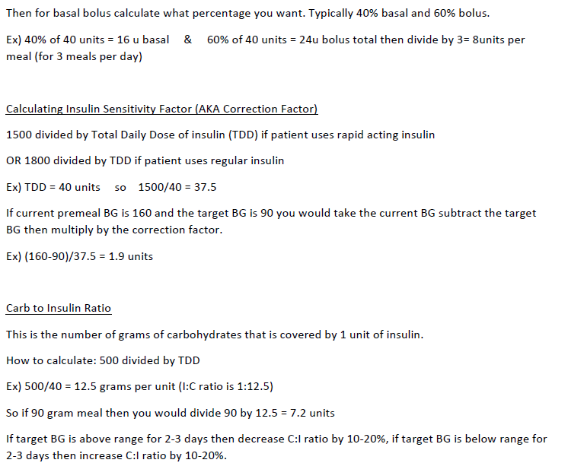
= 37.5 mg/dl/U = ISF ; divide by 18 for mmol/l/U
ISF
=> IC = 12.5 g/U => 8 U avg need for 100 g carb meal
IC

3.“Experimental” determination of IC at meal times

Attempts to define the IC factor via TDD (section 2.) can only yield a rough estimate, also because the influence of fats and proteins is often omitted, or done wrong, or applied inconsistently.
This is discussed in more detail in: “Meal-Management Basics.pdf” , see : https://github.com/bernie4375/HCL-Meal-Mgt.-ISF-and-IC-settings
To determine a meal bolus in Hybrid Closed Loop, best use an IC-factor which you determined for the relevant time-of-day window, as follows.
3.1 Basal rate first
Verify that you have a correct basal rate before determining factors!
This is important because you want to watch the effect of your meal bolus for at least 3 hours, and a basal rate error in that time window would bias your observations. Additionally, your observations would be burdened by any wrong basal values for a couple of preceding hours.
As a consequence, you would lose some of the principal power of your loop.

Helpful links regarding basal rate
- A basal rate helper, drawing data from your Nightscout site (by Peter van Rijt): https://www.nightscoutsuggestions.com/index.php
- a good article in support of that process: https://www.mysugr.com/en/blog/basal-rate-testing/
- a process description by a commercial service, including a tool : https://www.mevita.de/.../online-zugang-erstellung-einer.../

Although I advise to determine your true, likely circadian, basal rate:
It can be „good enough“, and advantageous especially for small kids, to simplify things and assume a (in case of doubt, low!) flat basal rate, together with a well-contoured ISF pattern („with enough bite where it counts“). Discussions on this topic can be found in looper sites using the search term “flat basal rate”. Interpret enthusiastic reports on flat basal with caution, though. Positive observed effects are likely coming from significantly increased attention to ISF and IC… and this brings us back to our topic...

3.2 Determination of your IC for each major mealtime
Make sure your basal rate is right. On a day without preceding major activity, stress, infection, and a relative steady glucose in the normal range (and cob=0) before meal start:
Shut closed loop off. (Open loop, with just the profile basal rate running).
Eat a well defined smaller meal (20 .. 45 g of preferably „rapid“ carbs; not much fat and protein, please) and use your suspected (see section 2) IC to determine the amount of insulin for this meal.
With Closed Loop off, but profile basal running (i.e. in Open Loop), watch for 3 hours.
(This assumes you use Lyumjev or Fiasp, at least in a 50% mix. The author never tried any slower insulin, which would be inferior for looping, and require longer time periods to observe desired changes, in tests as well as in everyday life!)
- If your glucose levels out about where you started, the IC can be used.
- If curve goes too low (eat some carbs and) try next day again, with a higher IC value.
- If curve remains too high, the IC was too weak, and needs to be lowered.
Using your ISF, you can calculate how many units of insulin less, or more, your IC rather should have provided to actually come to bg target. Units of bolussed insulin / desired insulin would be an estimate for the factor to adjust your IC. (This is for open loop testing. In closed loop you would have to factor SMBs, + TBRs deviatiing from 100%, in).
For testing carb ratios see also Katie di Simone (†) at: http://seemycgm.com/2017/10/29/fine-tuning-settings/ and Dr. Saleh Adi from Tidepool at: https://www.youtube.com/watch?v=McxO3oOkzc4

3.3 Using the IC to set a meal bolus
See instructions coming with the bolus calculator (or bolus wizard) that comes with your loop or pump. For AAPS, see here: https://androidaps.readthedocs.io/de/latest/Getting-Started/Screenshots.html#bolus-wizard
People who eat very carb-rich diets must give some consideration to the fact that the capacity of their body, how much carbs it can absorb per hour, is limited (in adults often to 30g/hour; see chapter 6.).
Also, there is a marked difference between insulins. Check (e.g. via the pink curve in the AAPS insulin tab) in which time window your bolus loses most of its activity.
For instance, for Lyumjev, at 120 minutes after injection already 75% of activity is used up.
So only a portion of the meal might be servable via a meal bolus given at the beginning.
The good news for high carbers on AAPS or other oref(1) systems: You can determine your everyday meal bolus by just dividing the g carbs that are absorbable while your bolus goes strong (for Lyumjev: 60g) by your IC, and “always” bolus that.
It is a frequently seen mistake that higher carb amounts (the entire meal) are entered (to 100%) into the bolus calculator. Subsequent tuning (to avoid hypos) makes people soften up (elevate) their IC, and their loop “lacks bite” as a consequence. ((You then experience higher bg, which could be counter-balanced with - at high bg - strengthened factors (dynamicISF/dynamic carb ratio). That way many come to a solution that may often look good enough. However you easy end up creating a maze of little errors and counter-balances to them, which makes your loop unstable! - The author advises to do a solid groundwork first, before resorting to extra “tweeks”))
PS: If you see merit in announcing more carbs right upfront, then make use of the % -to-be-bolussed-for button, and keep an aggressive IC intact.

3.4 What when your bolus wears out?
The IC- driven bolus should get you through the first 2-3 hours of a meal. (More see section 6 on tuning)
Challenges can arise after the 2nd hour when meal bolusses „wear out“ and Fat/Protein contributes.´ https://androidaps.readthedocs.io/de/latest/Usage/Extended-Carbs.html#extended-carbs-ecarbs
Regarding late meal phase see also Meal Management in https://github.com/bernie4375/HCL-Meal-Mgt.-ISF-and-IC-settings or also this study: https://www.ncbi.nlm.nih.gov/pmc/articles/PMC4454102/

3.5 Profile helper for kids

To help “construct” a circadian profile for kids, there is a “profile helper” in AAPS: https://androidaps.readthedocs.io/en/latest/Configuration/profilehelper.html#profile-for-kids-up-to-18-years
4. Determination of IC ratio via other factors (CRR, CSF, ISF)

In the preceding section we learned that determining suitable IC factors is not easy.
Size and composition of a meal, the selected insulin parameters, and roundabout 40 other factors occasionally present, can introduce variations in our attempt to define our IC.
In the following, therefore another factor is presented which is much easier to determine, and can serve to either determine the IC via an alternative route, or to provide a plausibility control.
The carb rise ratio (by some also called CSF, carb sensitivity factor) describes by how many mg/dl our glucose rises per gram of absorbed carbohydrate.
CRR is actually quite easy to determine (easier than the IC, which requires 3 hours with underlying stable glucose a correct basal rate, and rapidly absorbed carbs):
(In a relatively stable, normo-glycemic phase) take a sweet drink with a known carb content, and watch (in Open Loop, not giving any insulin except profile basal rate) by how many (mg/dl) glucose rises, until reaching a plateau (in about 1 hour).
Example: After taking 20g of carbs, bg rises from 90 to 190 mg/dl.
CRR = (190-90)mg/dl / 20g = 5 mg/dl / g
This parameter is of great value to check your ISF and IC values for plausibility, because:
ISF (mg/dl drop per U) / CRR (mg/dl rise per g carb) = IC (g carb / U)
or CRR = ISF / IC (Likewise of course in the mmol world)

I can now continue the „experiment“ (example above):
By treating the plateau of 190 mg/dl with an amount of insulin that suits my insulin sensitivity, e.g. 2 Units. Then I observe for about three hours (ClosedLoop off, profile basal running), until a new lower plateau is reached., For instance, a new plateau might build at 110 mg/dl, in which case 2 U of insulin brought me down by 80 mg/dl. My ISF would calculate to 80 / 2 = 40 mg/dl / U .
The IC would follow as: ISF / CRR = 40 (mg/dl)/U / 5 (mg/dl)/g = 8 g/U = IC

The CRR is relatively stable (does not vary by much over 24 hours): Both, ISF and IC, do vary (in similar ways, related to your insulin sensitivity), but when dividing on by the other, deviations owed to sensitivity cancel out.

5. Avoiding high glucose values

Even if your IC value is correct (brings you back to target about 2-3 hours after a meal), you might be disappointed by intermediate high glucose peaks.
Resist the temptation of extra bolussing when seeing a high peak! Rage bolussing comes with significant danger to run into a hypoglycemia a bit later.
Rather, try to picture for yourself the course of carb absorption on one hand, and of insulin activity developing, on the other.
See also “Meal Management Basics.pdf” in: (https://github.com/bernie4375/HCL-Meal-Mgt.-ISF-and-IC-settings).
Regarding insulin activity, AAPS displays that as a thin yellow line in your main screen if you select it (top right in your glucose screen press the little dart, activate Basal and Activity).
Regarding carb absorption it is important, that it starts before any insulin activity (hence always a rising glucose, initially), and then it can run rather steadily – in most adults at about 30 g/h as Dana Lewis has observed - Fat and fibre have an additional effect of stretching absorption out.

There are several strategies to minimize glucose peaks in the first hour or two after a meal:
- Pre-bolussing a couple of minutes before the meal starts However, this can be dangerous if timing (when eating “must, latest” start) is not strictly adhered to
This can problematic in restaurants, for instance, where you may need to “bridge” a delay being served …by going for any carbs in immediate reach.
- Give only a small part of the meal bolus before the meal begins. This enhances safety but increases complexity.
- Orient your loop, already an hour +/- 30 minutes before any meal, towards a lower glucose goal. This strategy has 3 nice benefits: (1) It lowers the starting glucose, so the peak from the meal will be accordingly lower (2) Moreover, you get some positive iob at meal start, further supporting a milder rise. (3) This move is very time-un-critical, and can even be automated for some of your meal times. ((Even if you skip a meal, nothing bad happens, other than that you need a snack in case you want to start exercise, rather than have a meal, when at the low range of your green glucose range))
- Full Closed Loop can, under certain conditions, and after significant tuning effort, also provide solutions (for advanced loopers, only. See https://github.com/bernie4375/FCL-potential-autoISF-research- )

6. Tuning IC in Hybrid Closed Loop

Following observations published by Dana Lewis *) , in the first 2 hours of nearly any meal, about 60g of carbs are absorbed, and – in HybridClosedLoop – a user bolus is there to largely take care. In this„main phase“ ,your IC should be tuned such, that your glucose curve hits the 3 green (X ):
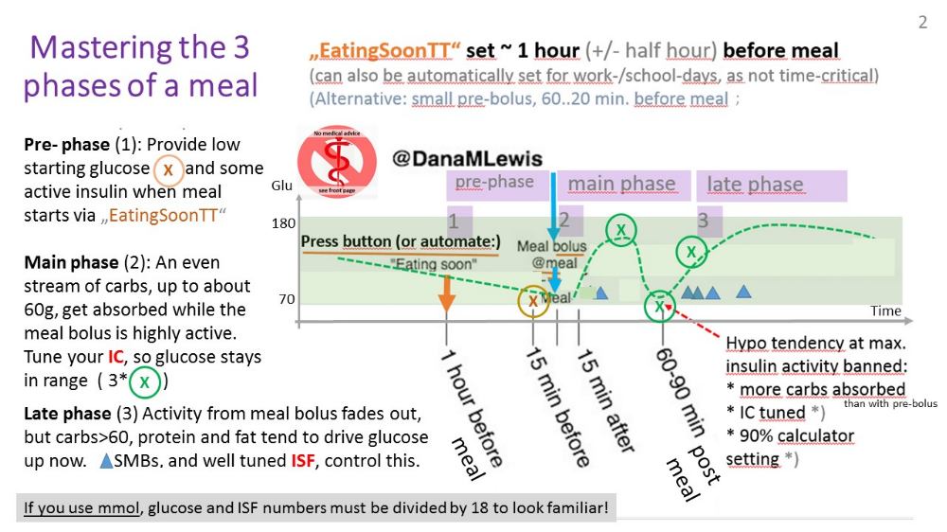

*) Chapter 8 in: https://github.com/danamlewis/artificialpancreasbook/ -

- Sensitivity adjusted IC (Carb Ratios)

7.1 Circadian 24 hour insulin sensitivity
Adults often have a „circadian“ pattern of insulin sensitivity „biorhythm“.
To “construct” your 24 hr circadian pattern, you can use a spreadsheet (supplied in AAPS Users FB by by Frank Duesterhoeft) if you like: https://docs.google.com/.../1BBOHfPFUzi4ButilakJY.../edit... Please download the sheet and open it with Excel. All you need ist to fill the red box on Tab 1 with your values and choose a distribution Nauck, Scheiner, etc.
Your average IC, or single, in the 24 h period experimentally determined ICs, may translate into a 24 hour pattern like this:
Example
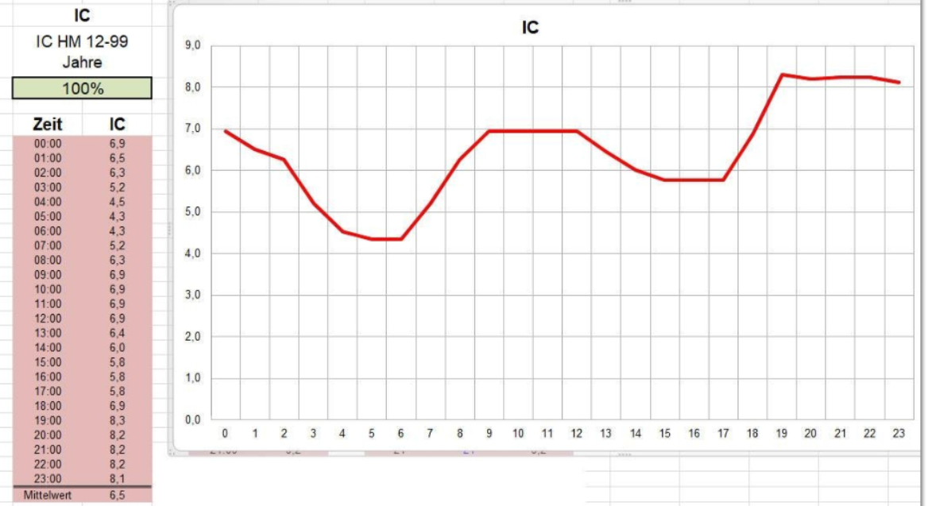
Note that lowest (most aggressive) IC is at times when your circadian basal should have highest hourly values (so, the basal curve looks inverse, mirrored on x axis).
For kids, the 24 hour sensitivity patterns can differ strongly from adults, and can also change strongly in certain growth phases. See examples given in “ISF determination..pdf” in: https://github.com/bernie4375/HCL-Meal-Mgt.-ISF-and-IC-settings
To help “construct” a circadian profile for kids, there is also a “profile helper” in AAPS: https://androidaps.readthedocs.io/en/latest/Configuration/profilehelper.html#profile-for-kids-up-to-18-years

7.2 Temporary effects on insulin sensitivity
Exercise , hormones, stress, (in)activity, infection ( and more, see “42 factors…pdf” in: https://github.com/bernie4375/HCL-Meal-Mgt.-ISF-and-IC-settings ) can temporarily change sensitivity to insulin.
However, because
InsReq ~ (Eventual bg – target) / ISF
the ISF per se may take care of adapting to temp. sensitivity changes, while the IC would play only a minor role:
- Note, that ISF drives insulin required directly (see formula above). In contrast, IC plays only a secondary role in how eventual bg is calculated:
- The loop knows exactly how much insulin was and will be active in each 5 minute segment
- bg delta / ISF = insulin consumed for the observed bg change (delta); only the other part of the observed delta_iob is ascribed to insulin used for carb absorption: absorbed g carb * IC = units consumed
- To the extent the g carbs absorbed do not fit a corridor defined by max carb/h and by min5m carb impact, the excess is ascribed to sensitivity effects (=>modulating IC and ISF until carb decay falls into the “allowed” corridor => Autosens shifts).
- The “UAM” part of the algo (UAM prediction) makes reasonable assumptions how calculated past carb absorption will continue and fade out in the next hour - and this is does every 5 minutes again, rolling forward. Very often that result is better than any user attempt at giving the loop precise info on grams of carbs, and their estimated absorption times. (Compare how your COB and UAM predictions develop after different meals!).
- g carbs inputs are not even needed at all (the loop either shows carb decay, or carb deviation), and also the IC value is not of great relevance (a lower one at high bg would lead to slower “hypothesized” carb decay; but, as the dialed-in IC (or the cob, if any – mine is always zero, in FCL) will not really change the bg development, in essence just more will be accounted as carb deviation in each of the 5 minute segments to follow)
- => Note: g carbs entered, and also the used IC, have only little, indirect influence on how the oref loop with UAM manages glucose!)
PS: For iOS Loop, carb data are of higher relevance, and the author would be happy to add a related chapter, or good reference.

7.3 Dynamic Carb Ratio

The story started with the observation that T1Ds use stronger ISF at very high bg (Chris Wilson original “27700 formula”). Quickly it was noticed (through observations by Tim Street and others) that in a looping context this formula needs refinements. A personal adjustment factor, and also the observation to serve more insulin on days with higher TDD eventually entered the formula for dynamicISF.
- Dynamic ISF is included in AAPS Master: https://androidaps.readthedocs.io/de/latest/Usage/DynamicISF.html#dynamicisf-dynisf . Note that AAPS at this time does not suggest to use dynamic carb ratio
- For a critical discussion on dynamic ISF, see e.g. “ISF determination...pdf” in: https://github.com/bernie4375/HCL-Meal-Mgt.-ISF-and-IC-settings
- In iAPS, both dynamicISF and dynamic carb ratio (IC) are offered: https://discord.com/channels/1120154740857245808/1123069312295510118

Regarding using dynamic carb ratio when determining bolus size, hybrid closed loopers should not forget the following:
- ISF is used to calculate the corrections (InsulinRequired), and the loop always applies caution in giving only 50℅ (then more 5 minutes later). So boosting ISF could be considered taking out some of this caution.
- However, the carb ratio IC is used mostly to determine a meal bolus = for a decision that is not every 5 minutes revisited. So, deviating much from what you had been working with in your profile seems not a good idea. (Better use the profile ICs, as were determined for each meal time)
- As it is good practice is to start meals always when bg is near target, no vast dynamic modulations of IC should happen in any case when determining a meal bolus
- Loopers should only bolus for carbs that actually get digested while their bolus is highly active. People who did that wrong in the past, had to retreat to softened IC values in their profiles. And on such basis, tightening things up now with dynamicCR can work. ((This would be a good example of two errors canceling eachother out, in tendency))
As argued already in section 7.2, dynamic carb ratio might be a superfluous concept also in UAM oref loops. Often, it seems a sub-optimal “late” solution to act more aggressive at bg that already got very high. Having more aggressive ((profile, and evtl. % situational by Autosens, or manually,-adjusted)) IC and ISF already at low glucose (i.e. when bg starts getting higher) could prevent bg going high in the first place.
auto_ISF can do the best job at that.
However, there clearly are anectodal reports from loopers benefitting using dynamicCR (and always concurrently used dynamic ISF). See https://discord.gg/mQH9SnfeRd
If you are interested, Join the Dynamic ISF AAPS Discord Server! for following some of the user reports on dynamic carb ratio.
To give you a glimpse into the debate there:
Chris Wilson Absent variation in meal incretin response (which governs the insulin-independent uptake of glucose from meals), the amount of insulin required to cause the uptake of a given glucose mass SHOULD vary with the base concentration of blood glucose, because the proportion of glucose disposal/uptake that is dependent on insulin scales with glucose concentration.
There are fundamental problems with the design of clamp studies that have resulted in the masking of the effects of glucose concentrations on insulin requirements. It’s an almost Schrodingerian paradox- the observation method affects the observed result.
Bjørn Ole Haugsgjerd I have also been looking at making CSF constant by scaling CR the same way as ISF. But my only reason to look at that was to hopefully improve the performance of the dynamic carb absorption model, since lowered ISF at high BGs will speed up the COB decay in oref0.

נצחיה סרי. There are definitely people that experience different insulin resistance when bg is high, among them are some that are really hungry when bg is high (my kid for example) and definitely eat then… .

Too often, people praising their dynamic factors do not make the effort to investigate, which part of the dynamic range was actually being used, and not falling into times of no insulin required, or cut by safety features like maxSMB size (minutes of basal).

In the end you must find for yourself, which of the available methods you want to use to temporarily adjust to changes in insulin sensitivity. The author finds dynamic carb ratio less convincing than other methods:
- Adjusting profile% to known stages of altered sensitivity, e.g. before, during and after exercise
- Using Autosens
- Defining Automations: When a certain “pattern” emerges, e.g. pointing to temp. resistance from fats after a big meal, then automatically set an elevated %profile for a couple of minutes (and again, as long as the condition exists).
- Using dynamicISF or autoISF

Good luck in developing your personal “good-enough” strategy for how you and your loop define insulin needed for carbs. Don’t get hung up in perfectionism, enjoy times with sufficiently good %TIR, as advised by your doctor.

8. Limited role of the IC in Full Closed Loop (UAM/no bolus/no carb inputs)

With detailed carb (amounts + absorption times) inputs, the loop has best-possible info to provide „the best expert fit“ of insulin activity and carb absorption.
It still rarely can come close to physiological values, because the time-delays inherent in our „artificial pancreas“, notably the stretched out DIA, make it difficult still, compared to a real pancreas.

So, precise carb inputs could help. However, only to the extent amounts and time pattern for absorption („eCarbs“) are correct ((which, every day, is a mission impossible))
Entering imprecise carb info could easy be inferior to not doing any carb inputs = to letting the UAM mode of oref(1) figure out further carbs that probably come to be absorbed in the next minutes, judging from the pattern of the calculated past carb deviations (see section 1.2.2 and https://openaps.readthedocs.io/en/latest/docs/While%20You%20Wait%20For%20Gear/Understand-determine-basal.html#understanding-the-basic-logic-written-version ).
PS: Because that is so, also loopers who do carb inputs get the UAM predictions besides their other predictions, and their algo makes a judgement (every 5 minutes) as to what the best calculation might be for where glucose, underlying „real“ carb absorption, and estimated carb deviation are headed.
In any case, well-determined IC values are nice-to-have also when using the dynamic carb decay model of oref(1), also when not making carb amount entries.

Full Closed Looping
Currently, looping without carb inputs and without giving a user bolus is only possible with good results when using the oref(1) algorithm’s SMB+UAM feature, as offered by OpenAPS, AndroidAPS and iAPS. (( iOS Loop, in contrast, requires fairly exact carb inputs )).
In Full Closed Loop (UAM/no bolus/no carb inputs), ISF (not IC) is the key factor for the loop to keep glucose in range.
The IC factor plays only a minor role there. However, the loop still uses it „in a side role“ for calculating deviations = to conclude how many carbs „must have been absorbed“ in each past 5 minute segment.
Note that the UAM Full Closed Loop is not clueless regarding how carb absorption will go on, even if you did not give it any “extended carb” entries, and your loop stubbornly sits at cob=0 all the time:
It will work with a prediction of further carb absorption building on the carb deviation (=hypothesis of how much got absorbed in the past 5 minute segments), and phase out more carb decay in the course of the next 1 to max 3 hours.
This was already discussed in section 1.2.2 on dynamic carb absorption. For more detail see https://openaps.readthedocs.io/en/latest/docs/While%20You%20Wait%20For%20Gear/Understand-determine-basal.html#understanding-the-basic-logic-written-version (or study your SMB tab info).

This UAM prediction about further carb absorption can be worse, but can also be better than a prediction based on the user‘s „e-Carb“ input in Hybrid Closed Loop.

In any case, and even when having perfect knowledge about how exactly the carbs fade out in the next hours, there would still be a principal problem for any loop:
- Heavy insulin „fire“ against highs will not work immediately (depending on the insulin’s time-to-peak), and notably it comes with a significant hypo danger (from the „tail“ of insulin activity.)
- A big bolus, or even a series of boli, will rarely work for several hours matching the absorption of carbs (from what, how much and and how fast the user ate).

